ΣΤΑΤΙΣΤΙΚΗ ΕΠΙΣΚΕΨΕΩΝ ΙΣΤΟΣΕΛΙΔΑΣ ΓΙΑ ΤΟΝ ΜΗΝΑ ΦΕΒΡΟΥΑΡΙΟ
- Οι επισκέψεις για τον μήνα Φεβρουάριο έφθασαν τις 47.509 .
- Ο μέσος όρος των ημερήσιων επισκέψεων είναι 1.697. ( νέο ρεκόρ μέσου όρου ημερήσιων επισκέψεων ).
- Ο μεγαλύτερος ημερήσιος αριθμός επισκέψεων έγινε στις 2 Φεβρουαρίου και έφθασε τις 3.165 .

Usage Statistics for www.eakp.gr
Summary Period: Last 12 Months
Generated 03-Mar-2009 05:18 EET

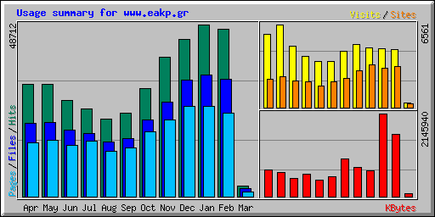
Summary by Month
Month | Daily Avg |  |  |  | Monthly Totals
Month | Hits | Files | Pages | Visits | Sites | KBytes | Visits | Pages | Files | Hits
Mar 2009 | 990 | 768 | 478 | 120 | 308 | 75114 | 362 | 1435 | 2306 | 2970
Feb 2009 | 1696 | 1187 | 846 | 164 | 3230 | 1609599 | 4615 | 23703 | 33257 | 47509
Jan 2009 | 1571 | 1112 | 822 | 149 | 3110 | 2145940 | 4636 | 25489 | 34489 | 48712
Dec 2008 | 1432 | 1067 | 821 | 152 | 3357 | 666070 | 4720 | 25462 | 33102 | 44404
Nov 2008 | 1313 | 893 | 722 | 167 | 2926 | 757956 | 5013 | 21666 | 26800 | 39396
Oct 2008 | 984 | 703 | 593 | 142 | 2279 | 980937 | 4421 | 18410 | 21798 | 30518
Sep 2008 | 787 | 551 | 456 | 122 | 2036 | 513827 | 3671 | 13707 | 16543 | 23617
Aug 2008 | 705 | 497 | 416 | 116 | 1722 | 434859 | 3624 | 12911 | 15422 | 21873
Jul 2008 | 800 | 575 | 505 | 131 | 2075 | 589122 | 4062 | 15676 | 17825 | 24803
Jun 2008 | 909 | 629 | 482 | 161 | 2138 | 475163 | 4849 | 14476 | 18885 | 27272
May 2008 | 1029 | 675 | 516 | 211 | 2429 | 613464 | 6561 | 16025 | 20935 | 31906
Apr 2008 | 1060 | 688 | 509 | 193 | 2258 | 680479 | 5800 | 15293 | 20643 | 31828
Totals |  |  |  |  |  | 9542530 | 52334 | 204253 | 262005 | 374808

Daily Statistics for February 2009
Day | Hits |  | Files |  | Pages |  | Visits |  | Sites |  | KBytes
1 | 1435 | 3.02% | 1052 | 3.16% | 634 | 2.67% | 129 | 2.80% | 116 | 3.59% | 141798 | 8.81%
2 | 3165 | 6.66% | 1735 | 5.22% | 1147 | 4.84% | 180 | 3.90% | 165 | 5.11% | 180652 | 11.22%
3 | 1711 | 3.60% | 1301 | 3.91% | 853 | 3.60% | 184 | 3.99% | 162 | 5.02% | 138894 | 8.63%
4 | 1584 | 3.33% | 1147 | 3.45% | 761 | 3.21% | 164 | 3.55% | 138 | 4.27% | 122987 | 7.64%
5 | 1601 | 3.37% | 1173 | 3.53% | 847 | 3.57% | 199 | 4.31% | 183 | 5.67% | 29856 | 1.85%
6 | 1788 | 3.76% | 1108 | 3.33% | 842 | 3.55% | 169 | 3.66% | 150 | 4.64% | 40680 | 2.53%
7 | 1336 | 2.81% | 904 | 2.72% | 633 | 2.67% | 126 | 2.73% | 108 | 3.34% | 29792 | 1.85%
8 | 1182 | 2.49% | 964 | 2.90% | 730 | 3.08% | 123 | 2.67% | 120 | 3.72% | 29783 | 1.85%
9 | 1685 | 3.55% | 1254 | 3.77% | 866 | 3.65% | 179 | 3.88% | 182 | 5.63% | 68703 | 4.27%
10 | 1855 | 3.90% | 1220 | 3.67% | 784 | 3.31% | 190 | 4.12% | 171 | 5.29% | 62848 | 3.90%
11 | 1979 | 4.17% | 1334 | 4.01% | 867 | 3.66% | 203 | 4.40% | 166 | 5.14% | 83123 | 5.16%
12 | 1452 | 3.06% | 1078 | 3.24% | 731 | 3.08% | 173 | 3.75% | 169 | 5.23% | 30425 | 1.89%
13 | 1769 | 3.72% | 1159 | 3.48% | 852 | 3.59% | 174 | 3.77% | 156 | 4.83% | 25096 | 1.56%
14 | 1364 | 2.87% | 1007 | 3.03% | 787 | 3.32% | 138 | 2.99% | 136 | 4.21% | 16573 | 1.03%
15 | 1433 | 3.02% | 1077 | 3.24% | 793 | 3.35% | 143 | 3.10% | 127 | 3.93% | 47841 | 2.97%
16 | 1594 | 3.36% | 1149 | 3.45% | 769 | 3.24% | 169 | 3.66% | 140 | 4.33% | 40812 | 2.54%
17 | 1569 | 3.30% | 1184 | 3.56% | 761 | 3.21% | 203 | 4.40% | 179 | 5.54% | 36688 | 2.28%
18 | 1700 | 3.58% | 1195 | 3.59% | 913 | 3.85% | 164 | 3.55% | 153 | 4.74% | 29046 | 1.80%
19 | 1660 | 3.49% | 1176 | 3.54% | 814 | 3.43% | 147 | 3.19% | 145 | 4.49% | 38515 | 2.39%
20 | 1663 | 3.50% | 1262 | 3.79% | 960 | 4.05% | 173 | 3.75% | 140 | 4.33% | 42215 | 2.62%
21 | 950 | 2.00% | 735 | 2.21% | 473 | 2.00% | 127 | 2.75% | 99 | 3.07% | 34116 | 2.12%
22 | 1700 | 3.58% | 1095 | 3.29% | 871 | 3.67% | 138 | 2.99% | 108 | 3.34% | 55917 | 3.47%
23 | 2733 | 5.75% | 1635 | 4.92% | 1292 | 5.45% | 191 | 4.14% | 158 | 4.89% | 60016 | 3.73%
24 | 1879 | 3.96% | 1361 | 4.09% | 966 | 4.08% | 171 | 3.71% | 149 | 4.61% | 89721 | 5.57%
25 | 1773 | 3.73% | 1428 | 4.29% | 1145 | 4.83% | 192 | 4.16% | 154 | 4.77% | 32732 | 2.03%
26 | 1935 | 4.07% | 1313 | 3.95% | 956 | 4.03% | 194 | 4.20% | 165 | 5.11% | 41022 | 2.55%
27 | 1543 | 3.25% | 1126 | 3.39% | 825 | 3.48% | 163 | 3.53% | 139 | 4.30% | 44041 | 2.74%
28 | 1471 | 3.10% | 1085 | 3.26% | 831 | 3.51% | 148 | 3.21% | 130 | 4.02% | 15705 | 0.98%

Usage Statistics for www.eakp.gr
Summary Period: February 2009
Generated 01-Mar-2009 05:18 EET

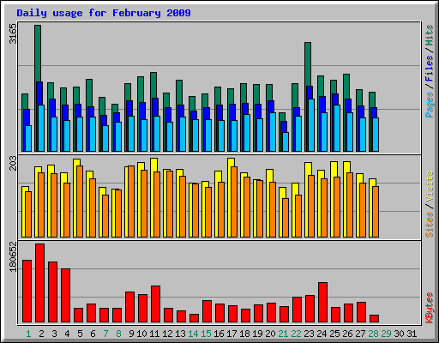

[Daily Statistics] [Hourly Statistics] [URLs] [Entry] [Exit] [Sites] [Referrers] [Search] [Users] [Agents] [Countries]
Monthly Statistics for February 2009
Total Hits | 47509
Total Files | 33257
Total Pages | 23703
Total Visits | 4615
Total KBytes | 1609599
Total Unique Sites | 3230
Total Unique URLs | 233
Total Unique Referrers | 125
Total Unique Usernames | 1
Total Unique User Agents | 313
. | Avg | Max
Hits per Hour | 70 | 758
Hits per Day | 1696 | 3165
Files per Day | 1187 | 1735
Pages per Day | 846 | 1292
Visits per Day | 164 | 203
KBytes per Day | 57486 | 180652
Hits by Response Code
Code 200 - OK | 33257
Code 206 - Partial Content | 51
Code 301 - Moved Permanently | 273
Code 302 - Found | 312
Code 304 - Not Modified | 6688
Code 400 - Bad Request | 3
Code 401 - Unauthorized | 657
Code 403 - Forbidden | 114
Code 404 - Not Found | 5929
Code 405 - Method Not Allowed | 225

